Client Line – Self Enrollment Process
In your browser window go to https://www.businesstrack.com/
Please contact the ClientLine help desk if you encounter difficulty with your enrollment: 800-285-3978
Here are the steps:
- Click on the *Enroll* button
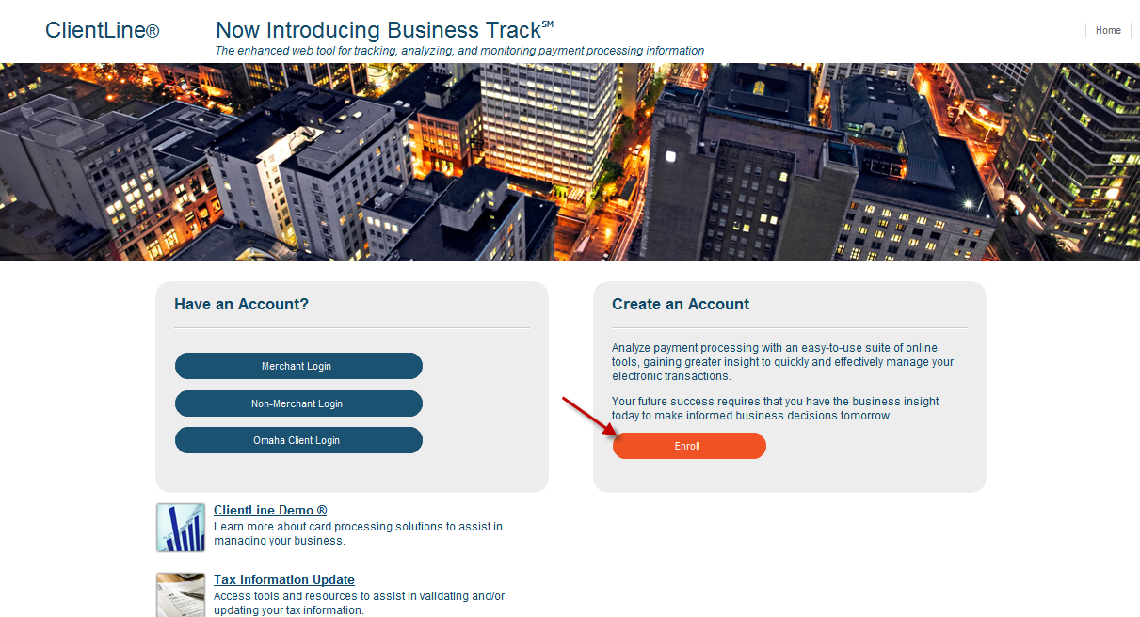

- In the Create an Account screen, click *Begin Enrollment*
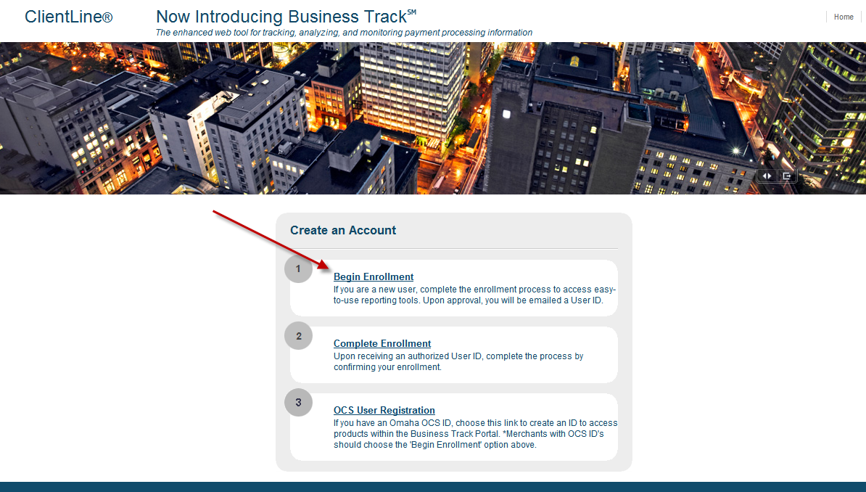

- Enter the qualifying information for your particular merchant account. If you have more than one account, you will enter the HQ (or lead) merchant account ID.
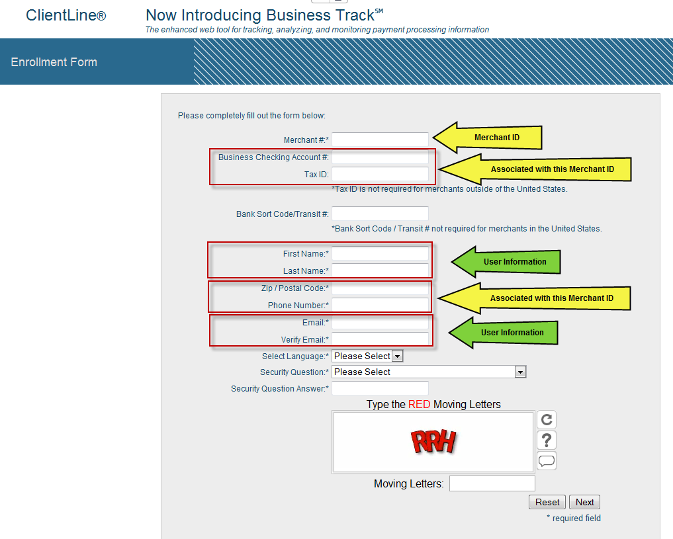

- Agree to Terms and Conditions and click *Next*:
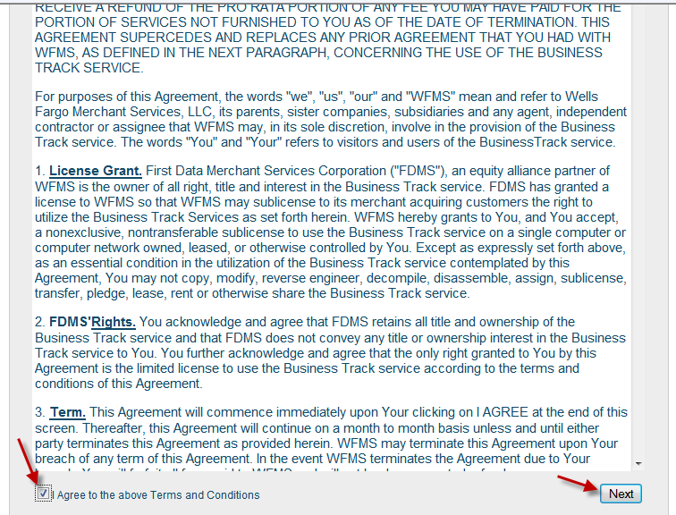

- Select applications: ClientLine Reporting plus any other desired applications and click *Next*:
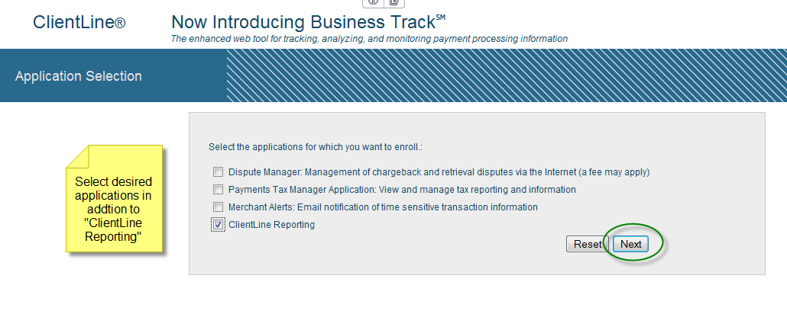

- User ID setup will begin.
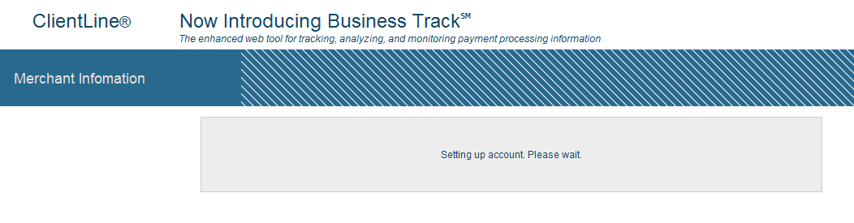
- Your user name and temporary password should be displayed. Record this information and click *Login*:
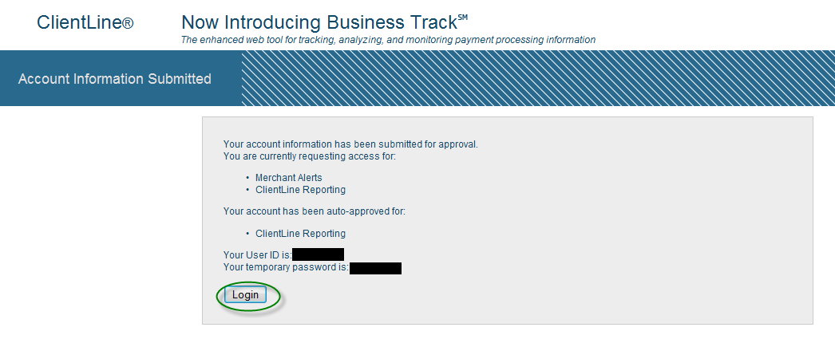

- Change temporary password to new password following format listed:
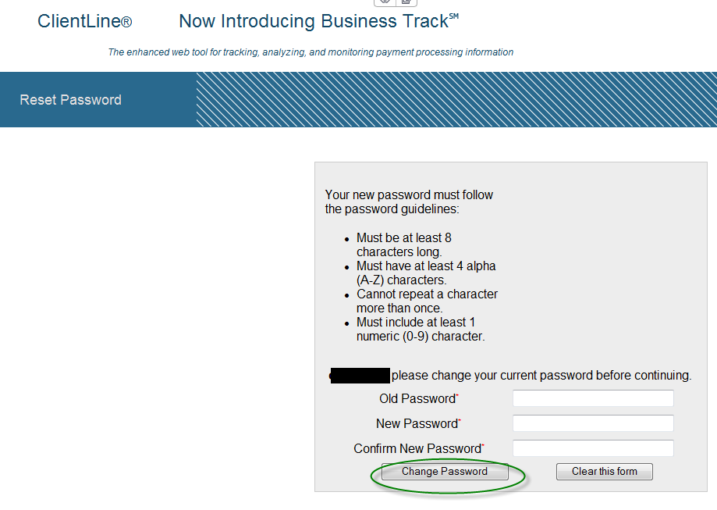
- Configure account alerts [if applicable].
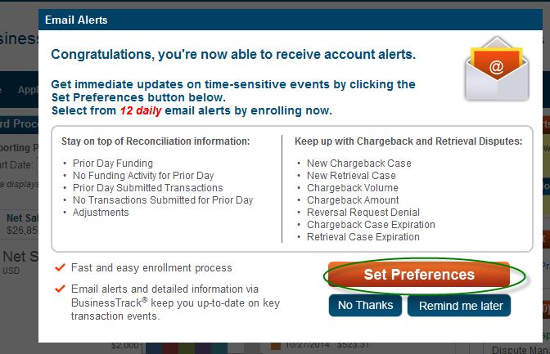
9a. Alert Preferences screen:
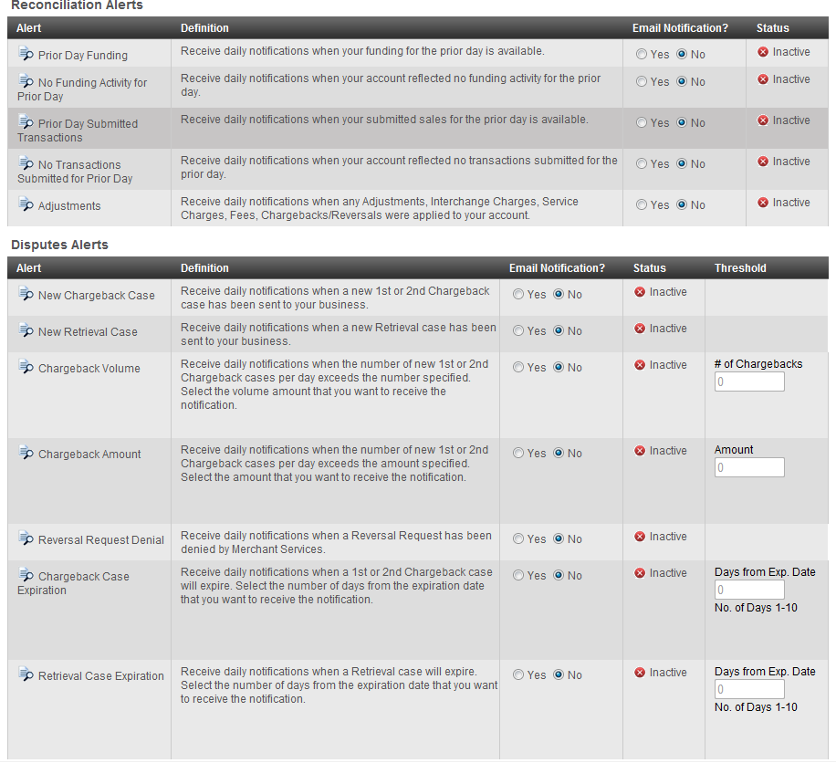
9b. Confirm Alert
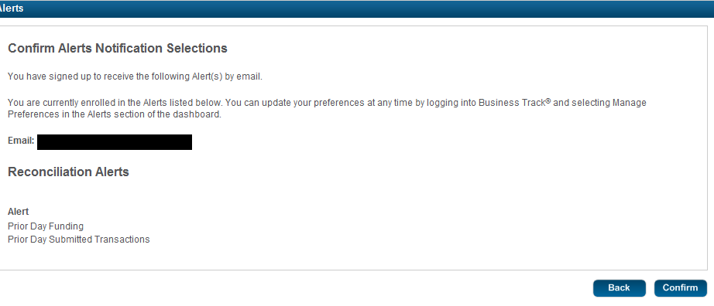
Please contact the ClientLine help desk if you encounter difficulty with your enrollment: 800-285-3978. Provide your Merchant ID number.
ClientLine/Business login and Demo screen
https://www.myclientline.net/welcome.html


